DEFECT LOGGING & TRACKING
Project: TOOLSHOP WEB APPLICATION

1. Project Details
Project Name | TOOLSHOP WEB APPLICATION
Application URL | https://practicesoftwaretesting.com/
Testing Type | Functional Testing
Testing Cycle | 28-Sep-2026 to 28-Oct-2026
Environment | Web – Chrome / Windows
QA Team | Halima Subaidha

2. Defect Logging
Defect ID | Module | Defect Summary | Severity | Priority | Status
DEF-001 | SIGNUP | Password strength indicator fails to update as user types | MEDIUM | MEDIUM | Open
DEF-002 | FORGOT PASSWORD | System displays text error "page.forgot-password.confirm" instead of redirecting to password reset confirmation page | HIGH | HIGH | Open
DEF-003 | PRODUCT DETAILS | Product comparison validation banner fails to display for the first item and does not enforce maximum limit warnings. | MEDIUM | MEDIUM | Open
DEF-004 | SIGN OUT | User should successfully signout and the page should return to Home page | HIGH | HIGH | Open

3.1 Detailed Defect Report
Defect ID | DEF-001
Defect Title | Password strength indicator fails to update
Module | SIGNUP
Reported By | Halima Subaidha
Reported Date | 03-10-2026
Severity | Medium
Priority | Medium
Environment | Windows 11, Chrome 154
Build / Version | Build 1.0
Status | Open
Assigned To

Steps to Reproduce
1. Navigate to the registration page.
2. Scroll down to the Password field.
3. Type a strong character sequence (e.g., Mix of uppercase, lowercase, numbers, and symbols).
4. Observe the password strength indicator bar/text while typing.
5. Click outside the input box (lose focus) and observe again..

Expected Result

The strength indicator should update instantaneously on every keypress to give immediate visual feedback.

Actual Result

Password strength indicator does not update while typing. The indicator updates only after the password field loses focus. Defect Evidence
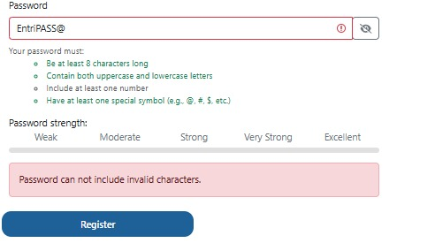

3.2 Detailed Defect Report
Defect ID | DEF-002
Defect Title | Reset password operation failed
Module | Forgot Password
Reported By | Halima Subaidha
Reported Date | 03-10-2026
Severity | High
Priority | High
Environment | Windows 11, Chrome 154
Build / Version | Build 1.0
Status | Open
Assigned To

Steps to Reproduce

1. Click on Forgot password link below sign in
2. Enter valid registered mail id on email text box
3. Click on SET NEW PASSWORD button

Expected Result

user shoudl receive reset password link to the registered mail id

Actual Result

The system fails to redirect the user and instead prints a raw localization key error message on screen: "page.forgot-password.confirm".

Defect Evidence
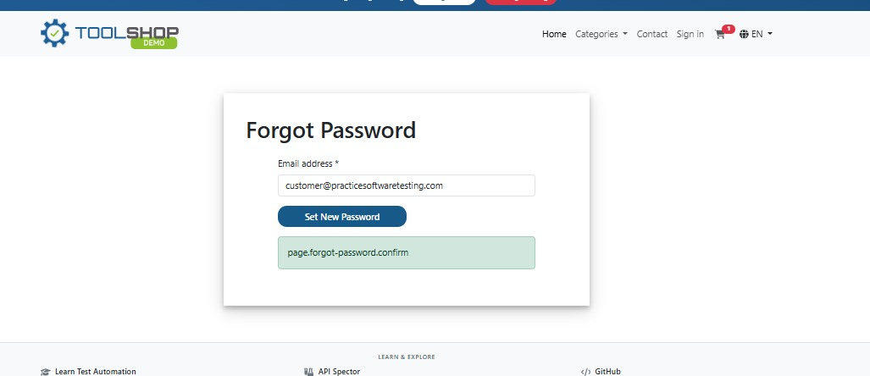

3.3 Detailed Defect Report
Defect ID | DEF-003
Defect Title | Boundar limit fails to update with added products in Compare feature
Module | Compare
Reported By | Halima Subaidha
Reported Date | 03-10-2026
Severity | Medium
Priority | Medium
Environment | Windows 11, Chrome 154
Build / Version | Build 1.0
Status | Open
Assigned To

Steps to Reproduce

1. Click on any product displays on the HOME page
2. Click on Compare button nearby the Product image
3. Click on Home link on top of the page
4. Click on any other product and again Click on Compare button nearby the Product image
5. Click on the compare all button from the validation message on the bottom of the page

Expected Result

1. The Product Detail page opens successfully.
2. When the first product is added to Compare, the selection confirmation/validation message does not appear.
3. The validation message appears only when the 2nd to 4th products are added.
4. After reaching/exceeding the maximum comparison limit, the application does not display any maximum-limit warning or restriction message.
5. The application does not properly enforce the maximum comparison limit.

Actual Result

The application does not properly enforce the maximum comparison limit. Also when the first item added there is no notifiaction saying 1 item added add 1 or more for comparison

Defect Evidence

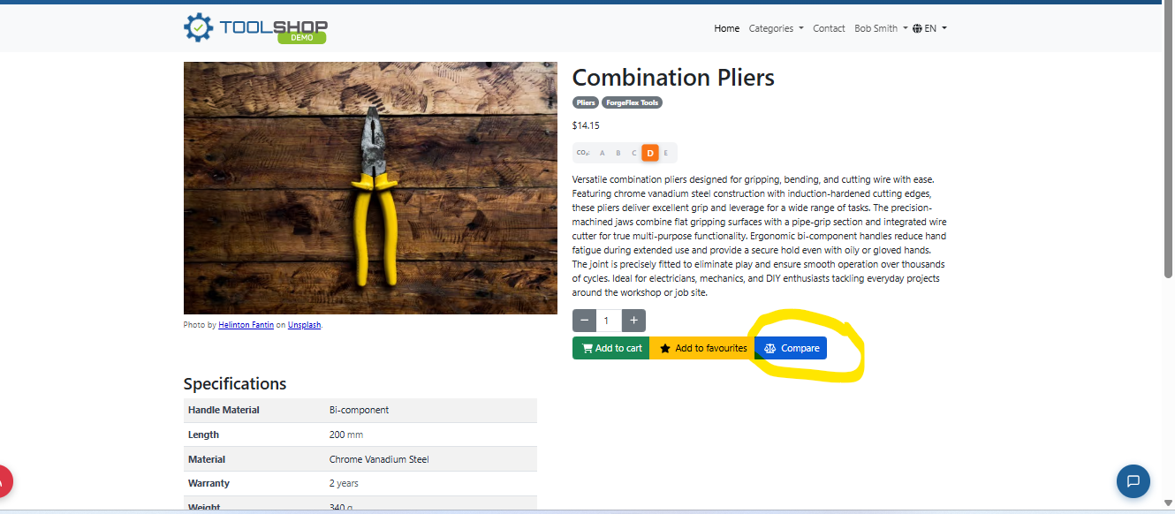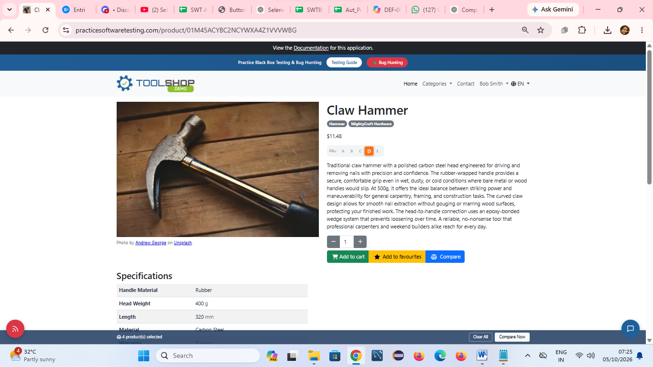

Reference images of selecting 1 item with no notification, try to adding 5th item wit no notification message of max compar limits

3. 4 Detailed Defect Report
Defect ID | DEF-004
Defect Title | Page not resetting ot home page after sign out
Module | Sign Out
Reported By | Halima Subaidha
Reported Date | 03-10-2026
Severity | Medium
Priority | Medium
Environment | Windows 11, Chrome 154
Build / Version | Build 1.0
Status | Open
Assigned To

Steps to Reproduce

1. Click on profile name on top right corner of the page
2. Select Sign out from the drop down menu

Expected Result

1. Drop down menu should display with GIVEN list of elements
2. User shoudl signed out immediately and the home page should open without any traces of the previously logged in customers activity

Actual Result

The system redirects to the main view, but the active shopping cart still persists and shows the explicit product details selected by the previously logged-in customer.

Defect Evidence
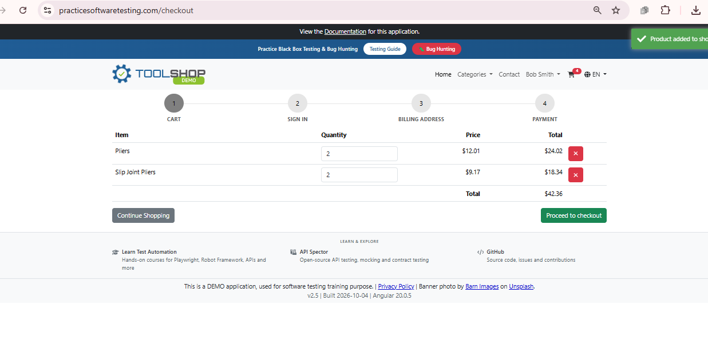
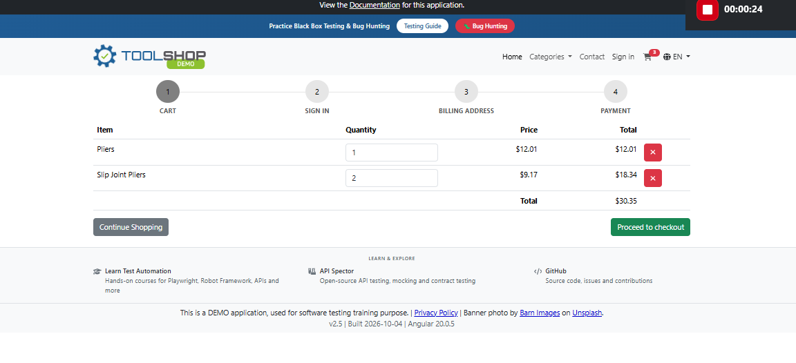

4. Defect Tracking Summary
Metric | Count
Total Defects Logged | 4
High | 2
Medium | 2
Low | 0
Open | 4
Fixed | 0
Retest
Closed | 0

